Want to run a PBEM tournament and don’t know how to build a website?
Here’s a quick and easy primer on how to create and maintain a free site using wordpress.com. Wordpress.com allows you to easily create and customize a website that will be accessible to anyone on the internet with a web browser.
- Go to http://wordpress.com and click Get Started
- On this page, provide your email address where you want to receive messages from the blog, including user comments.
- Create a user name to access wordpress
- Create a blog address like gametitletourney (e.g. twilightstruggletourney)
Your full website URL will be http://gametitletourney.wordpress.com

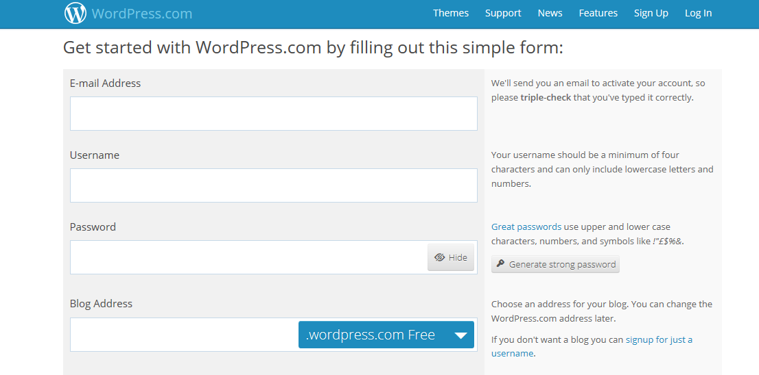

- Create at least one page with the tournament content. Each page will be accessible at URLs with the following format http://gametourney.wordpress.com/pagename.
- Create additional pages for each round of the tournament as necessary.
- You can create content in a word processing program (e.g. Microsoft Word) or a spreadsheet (Microsoft Excel) and paste it into the pages directly.
- Each page can accept comments and I have tournament participants use the comments page to register and report results.
- Wordpress has many themes and style layouts, but I recommend using Under the Influence as a simple clutter-free theme that provides a good layout for tournaments.

Example

Here is an example tournament site set up for the 2013-14 Hannibal: Rome vs. Carthage Play by Email Tournament. It has 3 pages set up, an about page, a tournament page, and a round 1 (rd1) page.

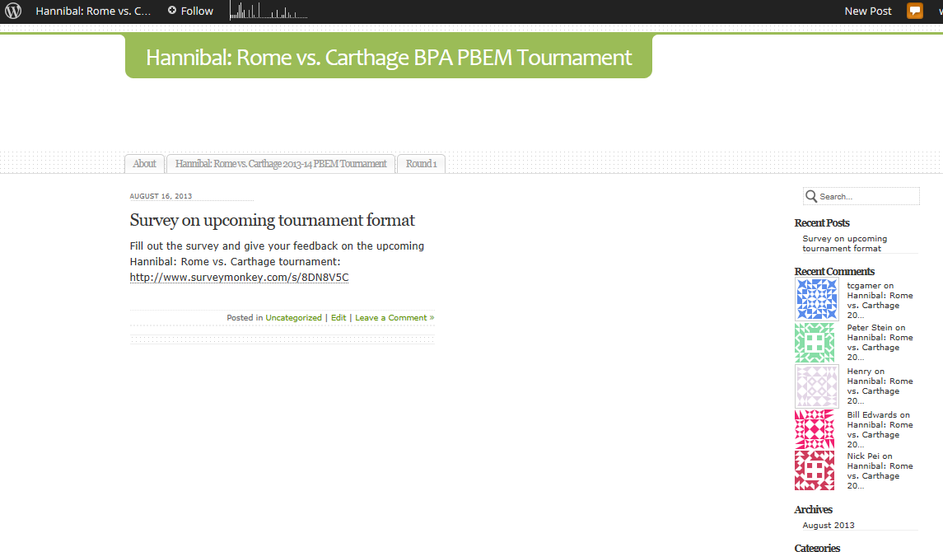
Tournament Page : http://hrctourney.wordpress.com/hrc1314/

(See PBEM Tournament Sample Description document)

Round 1 Page: http://hrctourney.wordpress.com/rd1/

About Page: http://hrctourney.wordpress.com/about/

Additional Resources
Wordpress has been around for several years now and there are many tutorial sites that can guide you through customization and putting additional features on Wordpress. Wordpress also has optional services for a fee that may be useful, though I have been satisfied with the free features.

http://www.ehow.com/how_6870642_build-website-using-wordpress.html
http://wpsitebuilding.com/

